Section 1: Basic Information
Captures primary entity details for identification and verification.
- Organization / Team Name: ResearchAI Innovators
- Entity Type (Startup / MSME / Educational Institution / Individual Innovator / Other): Student Innovators
- Registration Number (if applicable): N/A
- Date of Registration / Incorporation: N/A
- Official Website / Portfolio Link: LinkedIn:https://www.linkedin.com/in/vinay-kumar87/
GitHub: https://github.com/Gannavarapuvinaykumar
- DPIIT Recognition No. (if applicable): N/A
- Registered Address: Gumparru, West Godavari District, Andhra Pradesh – 534266
- State / District: Andhra Pradesh / West Godavari
- City / Town / Village: Gumparru
- Pin Code: 534266

Section 2: Point of Contact
The main person responsible for communication with the organizing team.
- Full Name of Contact Person: Vinay Kumar Gannavarapu
- Designation / Role: Team Lead (Student – B.Tech CSE)
- Email ID: gannavarapuvinaykumar@gmail.com
- Mobile Number: +91 6305862872

Section 3: Organization / Team Profile
Highlights who they are and what they do.
- Brief Company / Team Profile (100–200 words):
ResearchAI Innovators is a highly skilled 3-member technical team comprising Vinay Kumar, Karthikeya, and Samith, all B.Tech CSE students with strong expertise in Artificial Intelligence, Machine Learning, Full-Stack Development, and scalable backend architectures. The team specializes in building AI-driven solutions that address real-world challenges across governance, education, research, and cybersecurity.
The team has developed multiple production-grade AI platforms, including Haven AI, a behavioral wellness chatbot powered by NLP and ML-driven interventions; CipherCop, a national-level award-winning cybersecurity platform featuring phishing detection, malware analysis, and clone-site identification; Math Routing Agent, an intelligent multi-tier mathematical reasoning engine integrating semantic search and generative AI; and LearnSphere, an adaptive learning platform built using GPT-based models for dynamic module generation, personalized learning paths, and interactive quizzes.
Members of ResearchAI Innovators excel in microservices, cloud deployment, NLP pipelines, vector database integration, LLM orchestration, cybersecurity automation, and scalable backend systems using FastAPI, Node.js, Docker, and modern AI frameworks. Their achievements include securing a Top 10 rank at CipherCop 2025 National Hackathon conducted by BPR&D AND ISB, demonstrating the team's innovation, execution strength, and technical depth.

- Key Focus Area / Domain: AI/ML, NLP, Generative AI, Semantic Search, EduTech
- Number of Employees / Team Members: 3 (Student Innovators)
- Founding Year: 2025
- Key Technologies Used / Expertise:
• AI & NLP: AI4Bharat (IndicBERT, IndicBART), GPT-based models, embeddings, cross-lingual vector spaces
• Backend & Systems: FastAPI, Flask, Node.js, Express, containerized microservices
• Data Layer: PostgreSQL, MongoDB, Redis, Qdrant/FAISS
• DevOps: Docker, Linux, CI/CD
• Security & Authentication: SAML 2.0, RBAC, AES-256, TLS 1.3
• Other Expertise: OCR, semantic plagiarism detection, recommendation systems (ColaRec), federated API integrations (CrossRef, Scopus, Semantic Scholar, WoS)

- Notable Clients / Partners (if any): N/A — Student Innovation Team (Projects developed under academic and hackathon collaborations)

Section 4: Hackathon Participation Details
Focused on the current hackathon entry.
- Challenge Category Applying For (dropdown or multi-select): Collegiate Education – Smart Research Hub
(AI-Driven Platform for Research & Publication Excellence)
- Project Title / Idea Name: ResearchAI Nexus – Intelligent Research & Publication Platform for GDCs
- Problem Statement Addressed:
Government Degree Colleges (GDCs) in Andhra Pradesh possess substantial academic talent, yet research output remains low, fragmented, and lacking global visibility. Faculty and students spend disproportionate time manually identifying research topics, conducting literature reviews, verifying citations, detecting plagiarism, and selecting appropriate journals. The absence of structured digital research tools results in delays, inconsistent academic quality, and limited publication in reputable indexed journals such as Scopus and Web of Science.
A major barrier is the language divide—many GDC researchers work in Telugu, Hindi, Sanskrit, or Urdu, while global scientific literature is predominantly English. This linguistic mismatch restricts access to high-impact research, weakens literature reviews, and leads to poorly aligned research themes.
Additionally, researchers lack access to trusted metrics, such as impact factor, H-index, open access information, and journal reputation scores. This often results in submissions to low-quality or predatory journals, limiting international visibility and affecting the academic credibility of institutions.
There is an urgent need for a multilingual, AI-enabled research support ecosystem that streamlines topic discovery, automates literature insights, ensures originality through plagiarism detection, and guides researchers toward credible, indexed journals. Secure integration with the APCCE portal is essential to ensure authenticated access, academic integrity, and seamless faculty profile linkage.
The proposed platform addresses these systemic challenges, enabling GDCs to enhance research productivity, strengthen academic quality, and elevate Andhra Pradesh’s presence in the global research landscape.

- Brief Project Description (250–300 words):
ResearchAI Nexus is a multilingual, AI-driven platform designed to transform the research ecosystem across Government Degree Colleges (GDCs) in Andhra Pradesh by providing end-to-end automation and intelligence throughout the research lifecycle. The platform functions as a unified research companion—guiding faculty and postgraduate researchers from topic selection to final journal submission—while ensuring academic integrity, multilingual accessibility, and alignment with state research priorities.
The system integrates four advanced AI modules. The AI-Powered Topic Selection Engine uses a hybrid model combining Collaborative Filtering with a Strategic-Based Filter trained on Andhra Pradesh’s priority areas, ensuring that recommended topics are both globally relevant and locally impactful. The AI-Driven Literature Review Module employs a multi-stage LLM pipeline using IndicBERT, IndicBART, and domain-specific summarization models to analyze uploaded papers, extract key insights, map related works, and automatically organize literature.
The Plagiarism and Citation Engine utilizes a dual-pronged approach—Winnowing fingerprinting for exact-match detection and semantic similarity analysis using modern embedding models—to identify paraphrased plagiarism and generate comprehensive originality reports. The AI-Powered Journal Recommendation System applies a ColaRec-based content–collaborative model to rank journals based on Scopus indexing, Web of Science impact factors, open access status, and a computed “time-to-publish” metric, helping researchers make informed publication decisions.
Supporting Telugu, Hindi, Urdu, Sanskrit, and English, the platform leverages the AI4Bharat multilingual stack to break language barriers and enable cross-lingual semantic search and summarization. Secure integration with the APCCE portal via SAML 2.0 ensures authenticated login, role-based access control, and seamless researcher profile linkage while complying with the Digital Personal Data Protection (DPDP) Act, 2023 through encryption, masking, and ephemeral document handling.
By reducing manual effort, improving research quality, and enabling credible publication pathways, ResearchAI Nexus empowers GDCs to significantly enhance research productivity and elevate Andhra Pradesh’s academic visibility at the national and global levels.

- Business Process Flow
Step-by-Step Business Process Flow
1. User Authentication via APCCE Portal
- The faculty member or student logs into the APCCE portal using existing college credentials.
- APCCE acts as the Identity Provider (IdP) and issues a SAML 2.0 authentication assertion.
- The platform validates the SAML assertion and activates Role-Based Access Control (RBAC) to assign permissions (student, faculty, mentor, principal).

2. User Dashboard & Module Selection
After logging in, the user dashboard displays four modules:
- Topic Recommendation
- Literature Review
- Plagiarism & Citation Check
- Journal Recommendation
The user selects the module based on their research stage.

3. AI-Powered Topic Selection
- User enters keywords or research interests in any supported language (Telugu, Hindi, Sanskrit, Urdu, or English).
- The system performs cross-lingual semantic analysis using IndicBERT.
- The Hybrid Topic Engine (CF + Strategic-Based Filter) recommends high-impact, state-aligned research topics.
- User selects and saves preferred topics.

4. Literature Review Automation
- User uploads research papers or selects documents from search results.
- The system extracts structure (abstract, methodology, results) and generates:
  - Key insights
  - Summaries
  - Research gaps
  - Related works
- The content is translated into the user’s preferred language, if needed.

5. Plagiarism & Citation Checking
- User uploads draft content.
- The Fingerprinting Engine (Winnowing) identifies direct matches.
- The Semantic Similarity Engine detects paraphrasing and idea-level plagiarism.
- A detailed Originality Dashboard shows:
  - Similarity sources
  - Self-plagiarism
  - Citation corrections
  - Overall originality score
- User downloads the corrected draft or report.

6. Journal Recommendation
- User uploads abstract or manuscript title.
- The engine retrieves metrics from Scopus, Web of Science, Semantic Scholar, and CrossRef.
- ColaRec algorithm ranks journals based on:
  - Indexing (Scopus/WoS)
  - Impact Factor and CiteScore
  - Open Access status
  - Time-to-publish
  - Previous GDC publication history
- User receives a Top 10 journal list with full publication strategy.

7. Multilingual Output Delivery
- All insights, summaries, dashboards, and recommendations are returned in the selected language.
- Users can export reports as PDF/Word for thesis submission or publication workflows.

8. Analytics & Institutional Reporting
- Principals and researchers can view aggregated, anonymized insights:
  - Research trends
  - State priority alignment
  - Publication scorecards
  - Department-level research activity
This strengthens policymaking, monitoring, and institutional planning.
- Technical Architecture and Data Flow:
• Technologies / Tools Used
1. Backend Architecture
- FastAPI / Python → Core AI microservices
- Node.js (Express) → API Gateway & orchestration
- Docker & Docker Compose → Containerization
- Nginx → Reverse proxy and load balancing
- Redis → Caching for fast responses
- PostgreSQL / MongoDB → Metadata storage & logs
2. AI / ML Layer
- AI4Bharat IndicBERT & IndicBART → Multilingual NLU/NLG
- BERT / Mistral Embeddings → Semantic similarity
- ColaRec (Hybrid Recommendation Model) → Journal ranking
- Winnowing Algorithm → Document fingerprinting
- Scikit-learn / PyTorch → Model pipelines
3. External Academic Data Sources
- Scopus API → Indexing, CiteScore, OA status
- Web of Science JCR API → Impact Factor, Journal indexing
- CrossRef REST API → DOI metadata & licensing
- Semantic Scholar API → H-index, related works
4. Authentication / Security
- SAML 2.0 → Integration with APCCE portal
- RBAC (Role-Based Access Control) → Access permissions
- AES-256 encryption → Data-at-rest protection
- TLS 1.3 → Data-in-transit encryption
5. Frontend
- ReactJS → User dashboards & visualizations
- TailwindCSS / Material UI → Government-style UI
- Chart.js / ECharts → Analytics dashboard
• Functioning of Each Technical Component
1. API Gateway & Orchestration Layer (Node.js + Nginx)
- Serves as the unified entry point for all requests.
- Performs SAML token validation and forwards authenticated traffic to internal microservices.
- Manages routing, logging, rate-limiting, and service discovery.
- Ensures communication consistency and load balancing across services.
2. Authentication & Access Control Layer (SAML 2.0 + RBAC)
- APCCE portal acts as the Identity Provider (IdP) and issues SAML 2.0 assertions.
- The platform’s Service Provider validates digital signatures and extracts role attributes.
- The RBAC engine applies permissions for Students, Faculty, Mentors, and Principals.
- Controls feature access for research modules and analytics dashboards.
3. Multilingual AI Core (IndicBERT + IndicBART)
- Converts user queries and documents from Telugu/Hindi/Sanskrit/Urdu/English to a unified embedding space.
- Performs cross-lingual semantic search to retrieve related global literature.
- Translates AI outputs, summaries, and insights into the user’s preferred language.
- Supports all NLP tasks including embedding, semantic analysis, summarization, and translation.
4. Topic Recommendation Engine (Collaborative Filtering + Strategic-Based Filter)
- Analyzes user interests and previous APCCE researcher activity through Collaborative Filtering.
- Aligns topics with state-level priority domains using a Strategic-Based Filter trained on AP policy documents.
- Generates ranked research topic suggestions based on citation trends, relevance, and novelty.
- Uses embeddings to match user queries with global and regional academic data.
5. Literature Review Automation Engine (Multi-Actor LLM Pipeline)
- Separates uploaded papers into structural segments (abstract, methodology, results).
- Produces section-wise summaries using IndicBART fine-tuned for academic text.
- Identifies key insights, methodologies, research gaps, and related works.
- Integrates CrossRef and Semantic Scholar to retrieve external references.
6. Plagiarism Detection Engine (Fingerprinting + Semantic Similarity)
- Uses Winnowing fingerprinting to detect direct text reuse across public/internal repositories.
- Semantic similarity models detect paraphrased or concept-level plagiarism.
- Highlights matched segments with color-coded annotations.
- Generates structured originality and citation correction reports.
7. Journal Recommendation Engine (ColaRec + Federated Metrics Layer)
- Processes the user’s abstract using content-based embeddings.
- Combines academic metrics from Scopus (CiteScore, indexing), Web of Science (Impact Factor), CrossRef, and Semantic Scholar.
- Ranks journals using ColaRec’s content–collaborative generation mechanism.
- Calculates average “time-to-publish” using submission/publication metadata.
8. Federated Academic Data Layer
- Connects to multiple academic APIs (Scopus, WoS, CrossRef, Semantic Scholar).
- Normalizes and merges metadata into a unified schema for analysis.
- Provides real-time access to publication metrics, citation graphs, and OA status.
- Cached using Redis for high-performance retrieval.

9. Frontend Application (ReactJS + TailwindCSS)
- Provides a dashboard-based interface for topic search, literature review, plagiarism check, and journal recommendation.
- Supports multilingual UI rendering across all five supported languages.
- Allows users to download research insights, originality reports, and journal suggestions.
- Integrates charts, analytics, and institutional visualizations for faculty and principals.

• Flow of Data and Expected Outcomes at Each Layer
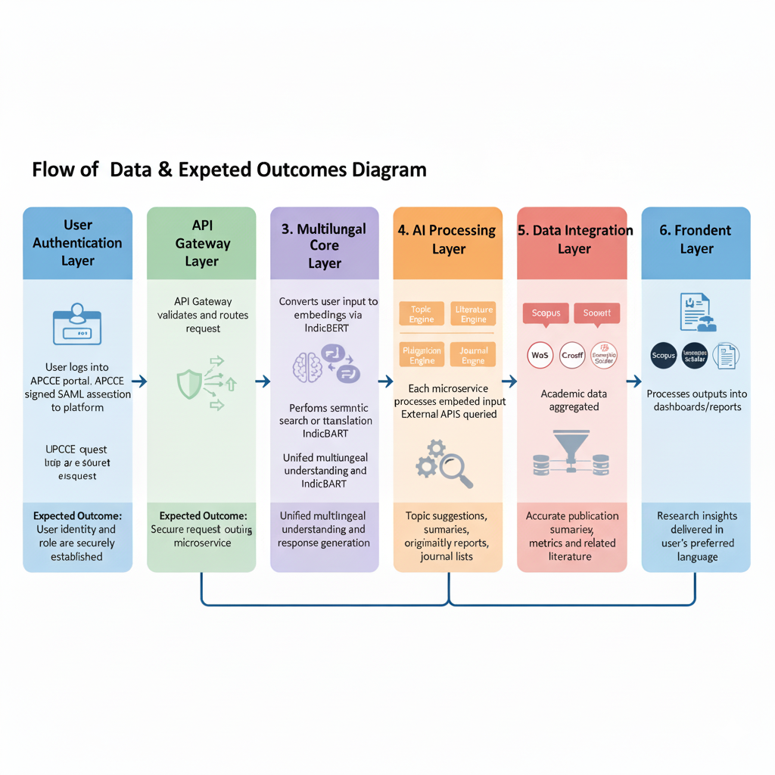

SYSTEM ARCHITECTURE
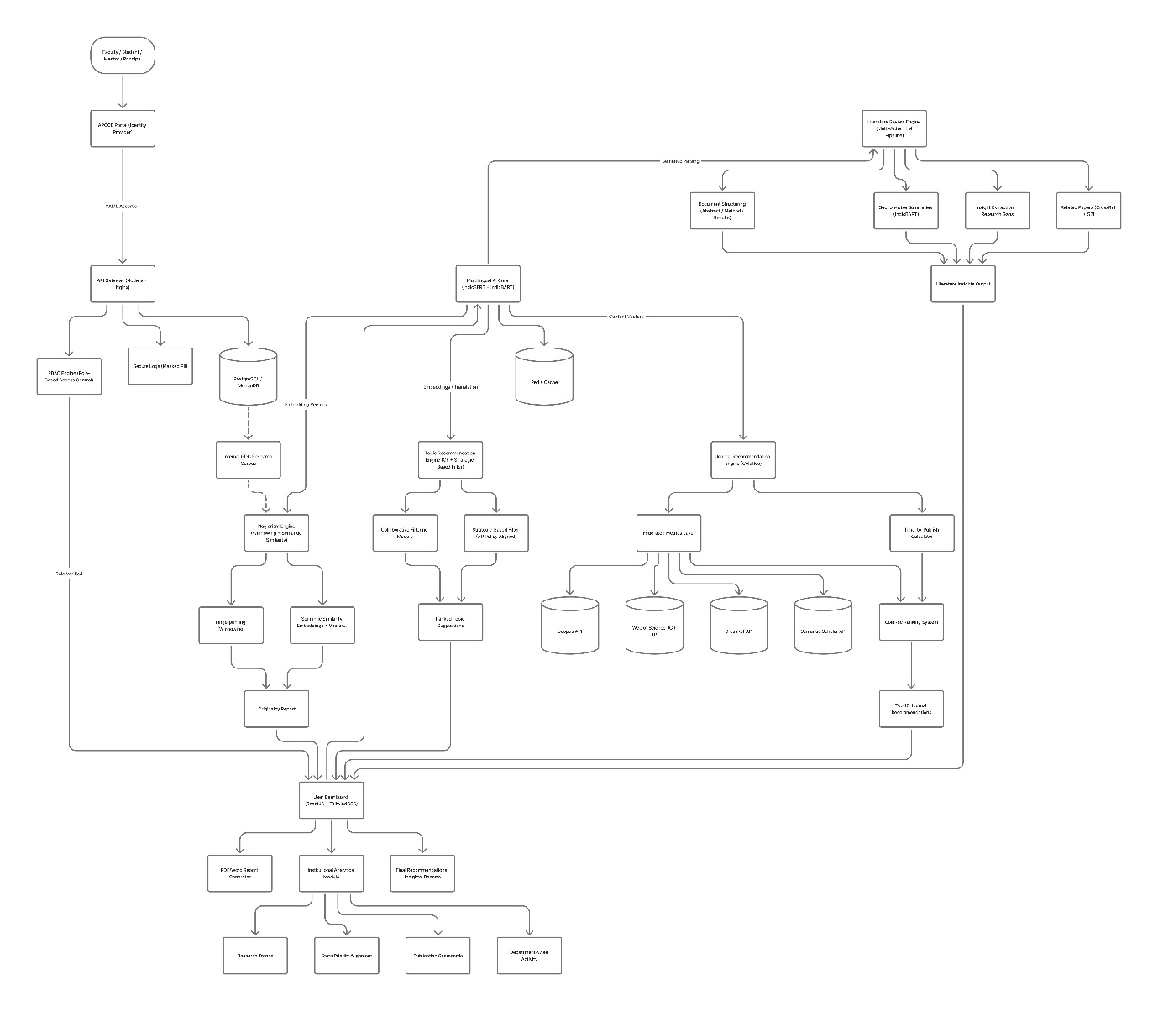

- Development Strategy/Timeline
🔵 Phase 1 — Foundation & Infrastructure (Week 1–2)
Week 1 – Environment Setup & Architecture
- Set up development environment (Docker containers, FastAPI, Node.js, React).
- Configure microservice architecture structure (API Gateway, services, internal routing).
- Initialize GitHub repository, CI pipeline, and deployment workflow.
- Begin APCCE SAML 2.0 integration documentation & certificate exchange.
Week 2 – Authentication & Multilingual Core
- Implement SAML 2.0 authentication flow with APCCE (staging environment).
- Configure Role-Based Access Control (student/faculty/principal).
- Integrate AI4Bharat IndicBERT & IndicBART for multilingual embedding and generation.
- Test cross-lingual semantic search (Telugu ↔ English).
🔵 Phase 2 — Core AI Modules (Week 3–5)
Week 3 – Topic Recommendation Engine
- Implement Collaborative Filtering module using synthetic GDC data.
- Develop Strategic-Based Filter (SBF) using AP policy documents.
- Combine CF + SBF to generate ranked topic suggestions.
- Build Topic Recommendation UI in React.
Week 4 – Literature Review Automation
- Implement document structuring and section extraction (Abstract/Method/Results).
- Use IndicBART for section-wise summarization and insight extraction.
- Integrate Semantic Scholar and CrossRef APIs for related-work mapping.
- Test multilingual summarization pipeline.
Week 5 – Federated Academic Data Layer
- Build connectors for:
  - CrossRef REST API
  - Semantic Scholar API
  - Scopus API (sample data for PoC)
- Implement metadata normalization and Redis caching.
- Prepare journal metadata repository for next phase.
🔵 Phase 3 — Plagiarism & Journal Engine (Week 6–7)
Week 6 – Plagiarism Detection Engine
- Implement Winnowing-based fingerprinting algorithm.
- Add semantic similarity detection using vector embeddings.
- Build Originality Dashboard (color-coded matches + report export).
- Test with benchmark papers & synthetic plagiarized samples.
Week 7 – Journal Recommendation Engine
- Build ColaRec-based content–collaborative model for journal matching.
- Integrate Impact Factor, CiteScore, OA status, and H-index from APIs.
- Implement “Time to Publish” calculation (submission → publication delta).
- Build Journal Recommendation UI with ranking and filters.
🔵 Phase 4 — Integration, Testing & PoC Deployment (Week 8)
Week 8 – Final Integration & User Testing
- Integrate all modules: Topic → Literature → Plagiarism → Journal.
- Conduct 8-user PoC testing across 5 languages.
- Fix usability issues and optimize latency & performance.
- Generate final PoC report:
  - Accuracy metrics (>80% target)
  - Language performance
  - APCCE authentication success
  - Plagiarism detection effectiveness

- Expected Impact / Outcome from this Hackathon Participation:
The ResearchAI Nexus platform is designed to bring meaningful improvements to how research is conducted across Government Degree Colleges (GDCs). Through this hackathon, our solution will demonstrate how AI can simplify complex research tasks, support multilingual users, and raise the overall quality of academic work.

✔ Faster & Easier Research
AI automation reduces the time needed for topic selection, literature review, plagiarism checking, and journal search, allowing faculty and students to focus more on meaningful research.

✔ Higher Quality Publications
With accurate summaries, reliable plagiarism detection, and smart journal recommendations, researchers can produce stronger, well-structured papers that meet global standards.

✔ Better Global Visibility for GDCs
By helping researchers choose reputable, indexed journals, the platform increases the chances of GDC publications reaching national and international audiences.

✔ Multilingual Accessibility
Support for Telugu, Hindi, Urdu, Sanskrit, and English ensures that every researcher — regardless of language — can access global academic knowledge without barriers.

✔ Improved Academic Integrity
Automated citation suggestions and originality reports promote ethical research practices across institutions.

✔ Insights for Institutions and Government
Aggregated analytics help principals and the Collegiate Education Department track research trends and align projects with state priorities.

✔ Scalable for Statewide Deployment
The platform’s modular, microservice-based design makes it easy to roll out across all GDCs in Andhra Pradesh and expand in future phases.

Section 5: Supporting Documents (Upload Section)
To validate and enrich the application.
- Company Registration Certificate (PDF): N/A
- Pitch Deck / Concept Note (PDF or PPT): https://drive.google.com/file/d/135FwnGXVGS9iG8fSCrWTdy2M3WjGB6JC/view?usp=sharing
- Demo Video (optional):

